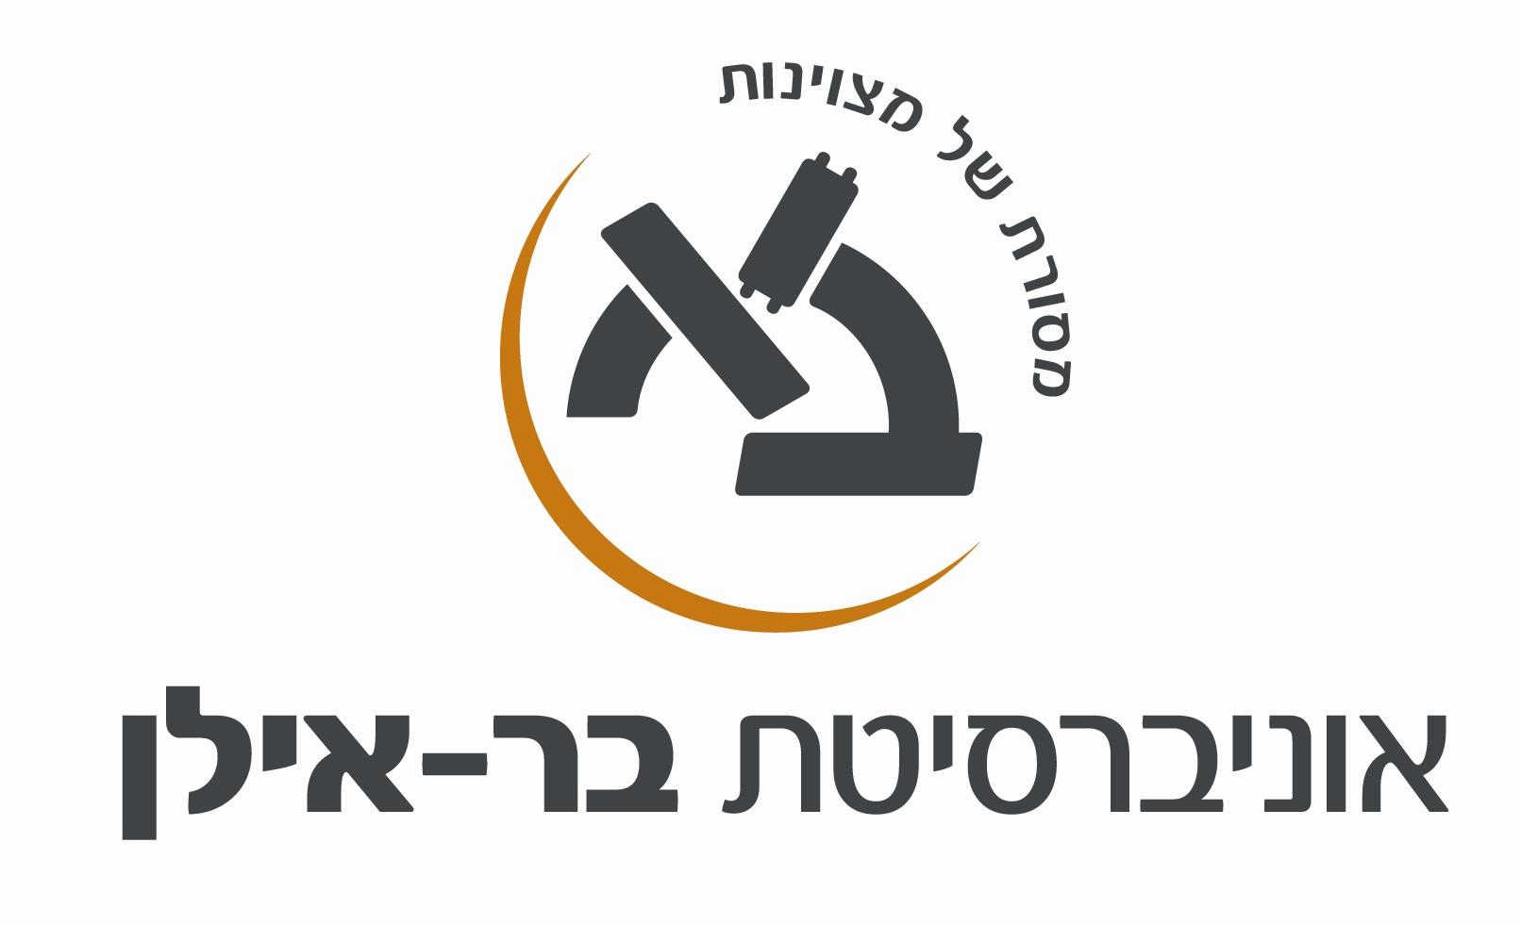
Course Name: English for Mitkadmim B (Advanced B)
Name of Instructor:
E-mail:

- מטרות הקורס (מטרות על / מטרות ספציפיות):
Course purpose and overview:

The main objective of the Mitkadmim B course is to improve students’ reading comprehension of academic texts. To this end, a variety of reading and language skills are taught and practiced throughout the course (see below). In addition to intensive reading, global reading techniques are emphasized to enable students to deal efficiently with large quantities of academic material. In addition, speaking, listening, and writing are integrated into the class sessions and assignments to develop effective communication skills.

- תוכן הקורס: (רציונל, נושאים)
מהלך השיעורים: (שיטות ההוראה, שימוש בטכנולוגיה, מרצים אורחים)
Teaching techniques, technology use, guest speakers:

- Frontal lectures
- Pair/group work
- Class discussions
- Moodle assignments (e.g. forum discussions, recordings, online quizzes, videos)
- Internet use: videos, supplementary material (in class/homework)
- Interactive class activities using mobile technologies

תכנית הוראה מפורטת לכל השיעורים: (רשימה או טבלה כדוגמת המצ"ב)
Reading strategies, language components, and related reading selections:

Below is a list of the reading and language skills and strategies practiced and taught in the course. The various components are taught and applied alone and in combination as needed (i.e. a skill/strategy may be taught in a focused lesson by itself, and then applied to various readings).

- Identifying various types of academic articles
- Pre-reading / Surveying / Predicting
- Reading introductions and conclusions to extract main idea, purpose, question and/or conclusion of texts
- Skimming long texts to search for information and/or to get the gist
- Paragraph structure (identifying main ideas and supporting details)
- Empirical research articles: structure and contents
- Summary and response writing
- Drawing inferences based on textual information and background knowledge
- Distinguishing between facts and opinions
- Meta-cognitive awareness of reading strategies and processes
- Reading fluency and speed
- Academic vocabulary
- Speaking and listening practice
- Writing answers, responses, and summaries

In addition, relevant skills from Mitkadmim A are briefly reviewed and practiced throughout the course as needed. These may include:

- Vocabulary skills (e.g. guessing meanings from context, affixes)
- Sentence structure (nominal phrases, simple, compound, and complex sentences)
- References and ellipsis
- Transitions and organizational markers

Reading selections are chosen from a collection of authentic academic texts taken from a variety of sources, including college textbooks and academic journals.

ג. תוצרי למידה:
Learning Outcomes:
Upon completion of this course, students will be able to do the following:

- Read and comprehend advanced authentic academic English texts
- Skim a long text to understand its main idea, purpose and conclusion
- Understand the structure of various types of academic texts
- Navigate authentic empirical research articles to extract relevant information
- Utilize oral and aural skills to effectively participate in class sessions and activities
- Interact with a degree of fluency with native speakers
- Understand spoken announcements, instructions, messages and short lectures
- Write short answers in English to demonstrate text comprehension
- Write structured paragraphs in English summarizing or responding to texts
- Produce clear, detailed texts on a wide range of subjects and explain a viewpoint
- Develop a clear argument, expanding and supporting his/her points of view with relevant examples

ד. חובות הקורס:
Course requirements:

- Attendance and active participation in class sessions
- Successful completion of class assignments, quizzes and homework
- Oral presentation
- Writing exam
- Final exam

ה. מרכיבי הציון הסופי
Components of the course grade:

The course grade is composed of a class grade (60%) and a final exam grade (40%).

The class grade includes:
- Reading comprehension: quizzes on vocabulary and reading strategies, sample "unseen" tests, homework, online assignments
- Listening and speaking: answering questions based on a video, recording short oral responses to reading, giving an oral presentation
- Writing: writing forum responses, summaries, short essays

Final Exam: The final exam consists of an “unseen” text of at least 3000 words. The duration of the exam is two hours. Students are allowed to use a dictionary during the test.

Bibliography:

Authentic academic articles compiled by each lecturer in a course booklet posted on the Moodle System

Articles chosen by individual students based on their individual needs

